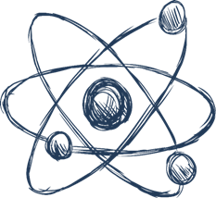
Year 6 Induction Task

When you come to Barr Beacon School, you’ll be having Science lessons in our laboratories. Here we complete lots of experiments and investigations. We then use this knowledge and our other understanding about Science to explain how the world around us works.
In Science there are three subjects you’ll be studying Biology (the study of living things), Chemistry (studying the substances that everything is made up of and how they react together) and Physics (studying structure of matter and how everything in the universe interacts)
To give you a taste of one of these sciences we want you to make a model of one of the following
- Biology – A Cell
- Chemistry – An Atom
- Physics – The Solar System

To help you out we’ve given you some success criteria (what you may want to include) and some pictures of examples.
Send a photograph of your model and a copy of any information you have found out to us – we look forward to seeing all of your amazing projects! Make sure you add your name and primary school to the documents that you send.

Biology – A Cell
Level | Criteria
Novice | Label the organelles (parts) of either a plant or animal cell
Apprentice | Find out what the function (job) of each of the organelles is
Journeyman | Compare your model cell to the other type of cell you could have made i.e. if you made an animal cell compare it to a plant cell
Master | Find out what a specialised cell is and research about 3 different specialised cells
Grand Master | Find out how people’s ideas about cells have changed over time
There’s some ideas on: https://www.wikihow.com/Make-a-Model-Cell
Chemistry – An Atom
Level | Criteria
Novice | Label the main parts of an atom
Apprentice | Find out more information about the main parts of the atom (their charge and mass)
Journeyman | Compare the size of the atom to other things in the universe
Master | Research is there is anything smaller than protons, neutrons and electrons
Grand Master | Find out how people’s ideas about the atom have changed over time
There’s some ideas on: https://www.wikihow.com/Make-a-Small-3D-Atom-Model
Physics – The Solar System
Level | Criteria
Novice | Include the names of the 8 planets in order
Apprentice | Describe the make up and conditions on each planet
Journeyman | Include other celestial bodies in our solar system (e.g. asteroids and comets)
Master | Describe other celestial bodies in the universe (e.g. galaxies and nebulas)  Discuss the likelihood of other living beings existing in the universe
Grand Master | Find out how people’s ideas about the solar system have changed over time
There’s some ideas on: https://www.wikihow.com/Create-a-Solar-System
Examples
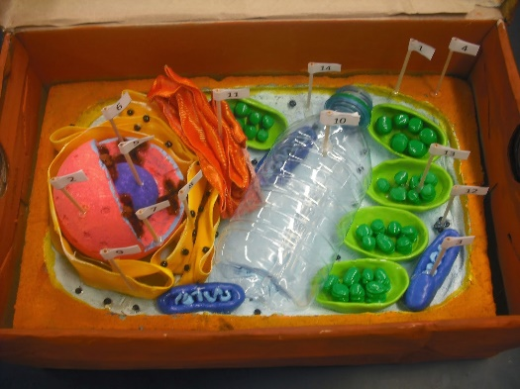
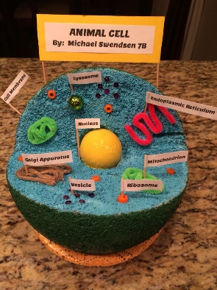
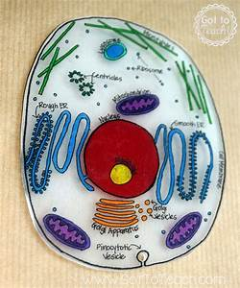
Biology – A Cell

Chemistry – An Atom
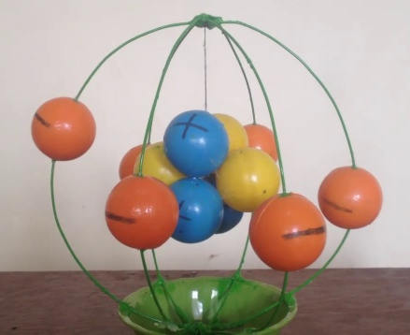
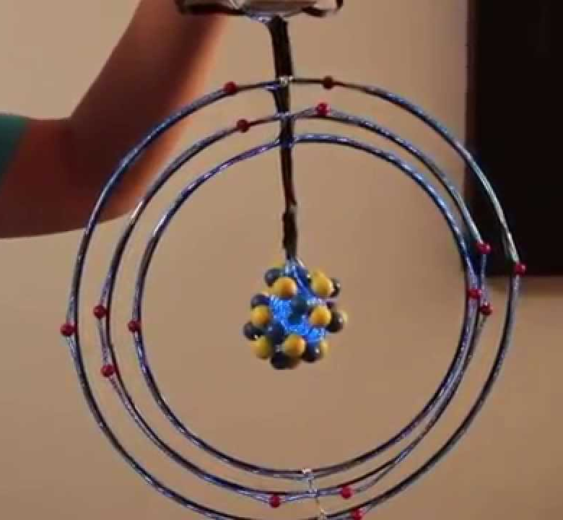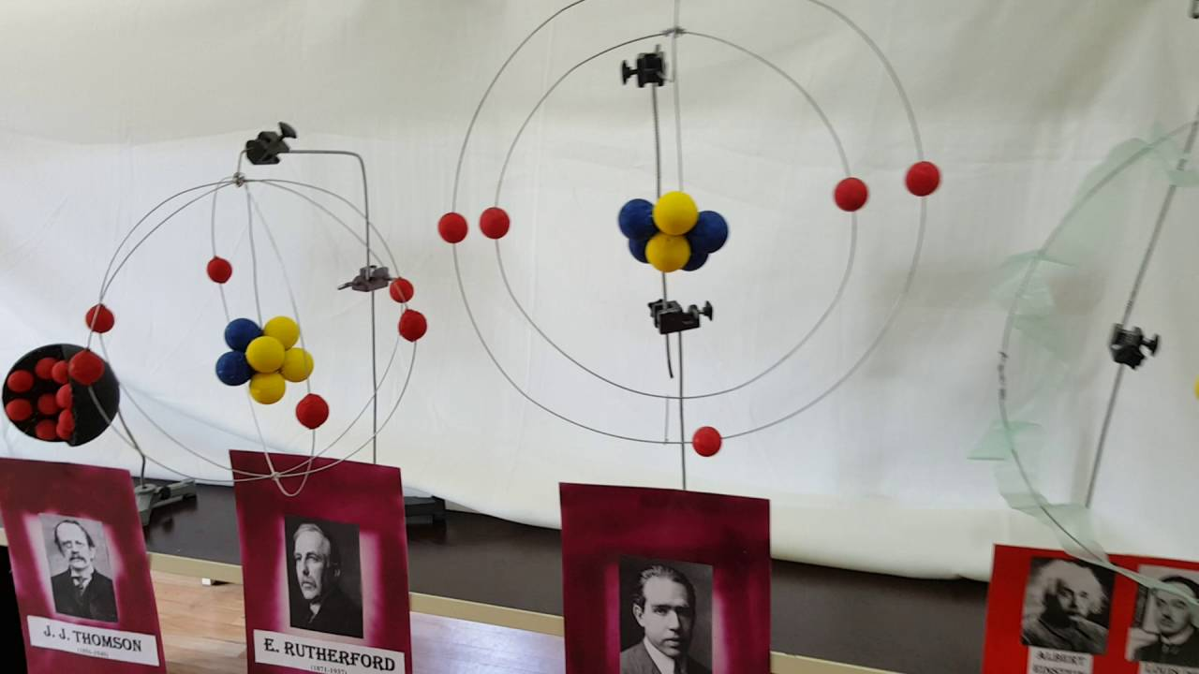

Physics – The Solar System
