Reading with your child
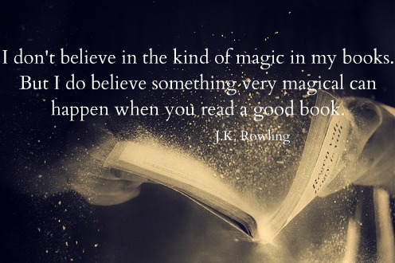

Many parents are asking how they can help their children over the coming months…
Being off work and at home is a wonderful opportunity to share reading together. Whilst families may be self-isolating or working from home, reading together is a bonding experience that can bring the family together.
If you make reading a priority in your home over the coming months, you will be helping to make sure that your child is continuing to develop their reading ability and vocabulary.
Agreeing a book between your family and even sharing this via skype, WhatsApp or email – you could even create a virtual book club!

Why read?
When we are young, we all love to be read to. As we grow older, some of us fall out of the habit of reading regularly. If you are away from work or school, this could provide you with that time to fall back in love with reading.
Reading time is time for just you!
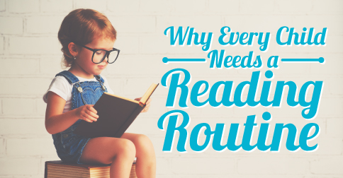
- Reading takes you on adventures, beyond the four walls of your home!
- Reading helps to build the imagination.
- Reading develops emotional intelligence and helps us to see other people’s points of view and ideas.
- Reading improves vocabulary….
….And the limits of our vocabulary are the limits of our world!
- Reading helps us to rest and relax.
- Reading takes our mind away from the outside world, which can sometimes be worrying and anxiety provoking.
- Reading trains the brain to be able to concentrate and focus, a skill that can be lost in an increasingly digital world.
Make time for yourself to read each day. Many people do this before bed to help them to unwind.
However, now is the perfect opportunity to reinvent your routine to allow you to read!

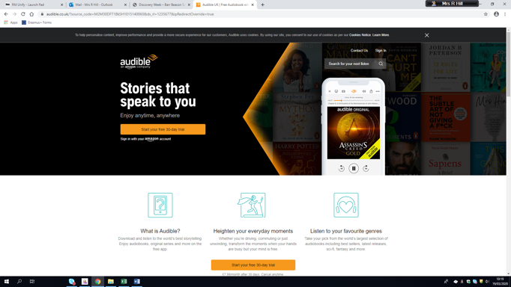
How to read together!
If your family has access to Kindles then this is the easiest way to all be reading the same book at the same time.
Before self-isolating, you could try to swap books with friends, family members and neighbours.
Stock up, if you can!
Audible is also very popular for some people, as they can listen to stories whilst they complete other tasks! Audible are offering a 30 day free trial at the moment.
Free audiobooks available here http://www.openculture.com/freeaudiobooks
- Nothing beats sitting with your loved ones and sharing the reading experience.
- We all love being read to!
- Read in silly voices
- Read the parts of the characters
The necessary conditions for reading
- Reading needs to be done in a place that everyone feels comfortable. On the sofa, on a beanbag, with a blanket and a warm drink.
- Reading needs to be done in a quiet and calm environment.
- Reading needs to be prepared for. Allow yourself the time and space to read a book. It’s you time!

Share the experience!
Ask each other questions about the characters, the plot and the writer’s main ideas.
Review what happened in each chapter: what has happened; why did the character make the choice they did; why did the character think what they did.
Predict what might happen next!
Check in with each other to see which parts of the story have shocked you, disappointed you, engaged you.
Find words that you haven’t fully understood, created a list of them together. Then look up the meanings and talk about them!
Find out about the author and why he or she wanted to write their book.
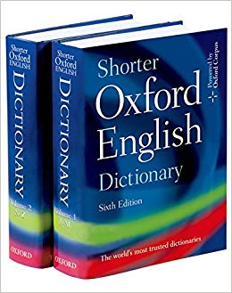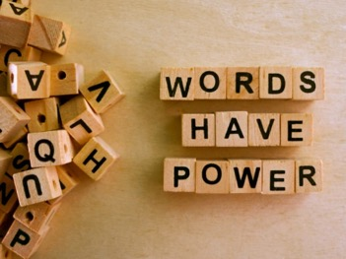
Once you have read it, share through the joy of film?

Netflix watchlist:
- Dickensian (adaptations of Dickens’s writings)
- Anne with an E (adaptation of L.M. Montgomery’s ‘Anne of Green Gables’ - Ms Collins’s favourite book of all time!)
- Emma (adaptation of ‘Emma’ by Jane Austen)
- Pride and Prejudice (adaption of ‘Pride and Prejudice’ by Jane Austen)
- Arrietty (anime adaption of ‘The Borrowers’ by Mary Norton)
- The Hobbit (adaptation of ‘The Hobbit’ by J.R.R. Tolkien)
- The Perks of Being a Wallflower (adapted from the novel by Stephen Chbosky)
- Mary Shelley (a biopic of the author of ‘Frankenstein’)
- The Great Gatsby* (adapted from the novel by F. Scott Fitzgerald)

Other:

- Watch theatre productions online: https://www.whatsonstage.com/london-theatre/news/stage-shows-musicals-opera-free-stream-online_51198.html (definitely check out the recent and ongoing production of The Wind in the Willows which has been made available for free online specifically because of social distancing!)
·

What to read
School Reading List
This website contains recommendations by year group to select from. These are quality books and many are classics.
https://schoolreadinglist.co.uk/reading-lists-for-ks3-pupils/suggested-reading-list-for-year-7-pupils-ks2-age-11-12/
Project Gutenberg
This website offers free ebooks of classic literature https://www.gutenberg.org/browse/scores/top
·
Read Brightly
This website recommend classics for teenagers that are accessible, relevant and enjoyable as well as providing some level of challenge for their reading.
https://www.readbrightly.com/classics-for-teens/
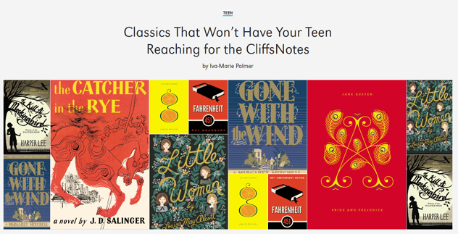
Waterstones Bestsellers for Teens and Young Adults
https://www.waterstones.com/category/childrens-teenage/teen-and-young-adult?page=1
These are also books often taught in Key Stage 3 as well as enjoyed and recommended by many English teachers!
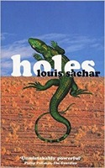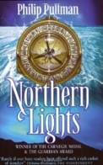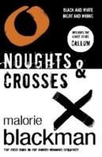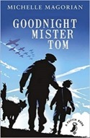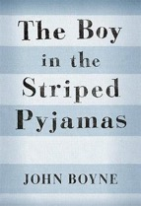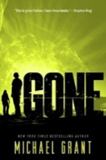
Holes The book focuses on an unlucky teenage boy named Stanley Yelnats, who is sent to Camp Green Lake, a juvenile corrections facility in a desert in Texas, after being accused of theft.
Northern Lights Set in a parallel universe, Lyra Belacqua journeys to the Artic in search of her missing friend Roger Parslow and uncle, Lord Asriel. The Magisterium have been conducting experiments with a mysterious substance known as ‘Dust’….
Noughts & Crosses is set in a fictional dystopia. The series describes an alternative history in which native African people had colonised the European people in an alternative 21st-century Britain.
Goodnight Mister Tom Set during World War II, a London boy is evacuated to the country at the outbreak of the war. In the care of Mister Tom, an elderly recluse, he experiences a new life of loving and care.
The Boy in the Striped Pyjamas A Holocaust novel told from the perspective of a young boy who innocently befriends another boy living in a concentration camp. The book highlights how young people can often be the victims to politics that they can’t understand.
Gone is centred on the fictional Southern Californian town of Perdido Beach, in which every human aged 15 and older vanishes. The town and surrounding areas become encased within an impenetrable barrier that burns to the touch, with many of its inhabitants developing supernatural powers.

Spring reading suggestions

The serious bit: Why does reading matter?
Studies show that reading for pleasure makes a big difference to your educational performance. Evidence suggests that those who read for enjoyment every day not only perform better in reading tests, than those who don’t, but they also develop a broader vocabulary, increased general knowledge and a better understanding of other cultures. (Pearson UK 2019)
Some suggestions that might interest you, and that may be linked to a range of different subjects include:

Easier reads/Getting started:
- Get Coding! By Young Rewired State – The book guides you through completing six 'missions' and discovering how to create an app or a game to your own design. [LINKS TO COMPUTER SCIENCE]
- The Neverending Story by Michael Ende – A fantasy novel that was originally written in German and then later translated into English. [LINKS TO ENGLISH AND GERMAN]
For intermediate readers:
- The Diary of a Young Girl, also known as The Diary of Anne Frank, is a book of the writings from the Dutch language diary kept by Anne Frank while she was in hiding for two years with her family during the Nazi occupation of the Netherlands. [LINKS TO GERMAN AND HISTORY]

- The King of Shadows by Susan Cooper –a talented young actor, arrives at the newly rebuilt Globe Theatre in London to play Puck in Shakespeare’s A Midsummer Night's Dream. As rehearsals begin, eerie echoes of the past begin to haunt the main characters, and he falls ill with a mysterious sickness. [LINKS TO DRAMA AND ENGLISH]
- The Simpsons and their mathematical secrets by Simon Singh. You may have watched hundreds of episodes of The Simpsons (and its sister show Futurama) without ever realising that they contain enough maths to form an entire university course. Singh analyses such memorable episodes as 'Bart the Genius' and 'Homer³' to offer an entirely new insight into the most successful show in television history. Simon Singh talks about the Mathematics of the Simpsons at Google: https://www.youtube.com/watch?v=bk_Kjpl2AaA [LINKS TO MATHS]

- Coding Games in Python by DK. Each chapter in Coding Games in Python shows how to construct a complete working game in simple numbered steps. [LINKS TO COMPUTER SCIENCE]
More challenging reading
- The Hunchback of Notre Dame by Victor Hugo - Rejected by fifteenth-century Parisian society, the hideously deformed bell-ringer Quasimodo believes he is safe under the watchful eye of his master, the Archdeacon Claude Frollo. An emotionally stirring story, Victor Hugo's The Hunchback of Notre-Dame is rightfully considered to be one of the finest novels ever written. [LINKS TO HISTORY AND FRENCH]

Why not write a mini review of what you have read?
Name: Form:
Subject that you have done reading related to/inspired by: (may be taken from the list above): | The book I read was: | My star rating: | Complete a short  style review of each text:
Example: Humanities - History | The Diary of Anne Frank |  | AnneFrank: What a truly amazing read although completely heart-breaking too.

