Year 6 English Transition Tasks

Task 1 - An ACROSTIC poem:
An ACROSTIC poem is when the first letters of the line spell out a word or phrase. Can you write an acrostic poem about your hopes for starting secondary school?
Try to write about the things you are looking forward to and what you hope to achieve while you are here. You could use CLASSROOM, SCHOOL, UNIFORM, BARR BEACON or another word to do with your aspirations as the basis of your poem. You can illustrate your poem when you have finished too if you like. Here’s an example:
Sitting in a classroom making new friends
Clubs for every interest,
Hungry for exciting lessons
Organised and punctual always!
On this exciting journey to success,
Laughter and learning in English lessons.

Task 2 - Create a product and advertisement (This can be completed on paper or on the computer):
- Your task is to design a new backpack that students could use when they go back to school. You will need to think about the following:
- Who is my bag for? Boys? Girls? Unisex?
- How can I make my bag different from the rest?
- What design will I put on my bag?
- How much will it be?
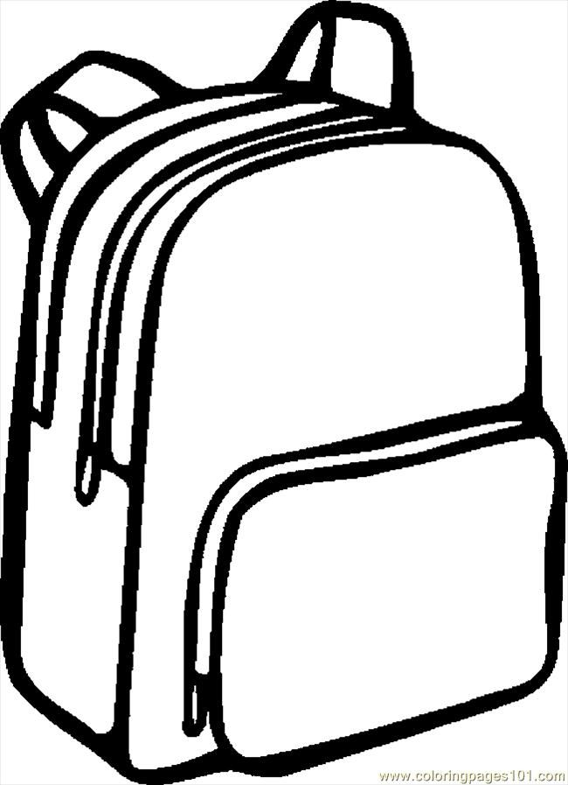
- Feel free to use the template here to design your bag (you can use a different design if you wish). You can be as creative as you want to with this bag design and include a wide range of features that will appeal to your age. For example:
- Built in speakers/headphones
- Built in hand sanitiser dispenser
- The bag can change colour depending on your mood.

- Create an A4 page advert to help sell your product to parents! It needs to include:
- Language devices (alliteration, rhetorical questions, repetition)
- Price
- Give a brief description of the product
- Why do they need this bag in their life?

Extension Task - The Poetry By Heart Summer Challenge:
1. Find a poem you love
Go to www.poetrybyheart.org.uk. Explore one or more of the collections of poems and find a poem you love, or, like a new friend, one you quite like and want to get to know better.

- The Poetry Mix-It-Up. Hover over some tiles and let the lines draw you in. Click on the mix-it-up and see what else you can find.
- The Yellow, Green and Red Timelines. Time travel. Yellow for younger pupils. Green for growing pupils. Red for really old pupils.
- The First World War Showcase. Poems written at the time and poems looking back to it, from people who experienced it from in different countries, languages and perspectives.
- The Shakespeare Sonnets Showcase. Fourteen lines, dressed to impress.

2. Learn it by heart
There's no short cut to this. Like getting to know a new friend, you have to make time to do things together. Read your poem aloud to other people, illustrate it, write out the lines and stick them on the fridge door. Remember its sections as if they are scenes in a slow-motion movie or rooms in a house. Repeat the lines while you're walking the dog. Recite it to the dog or in the shower or in front of a mirror. Give someone else the poem and get them to test you. Great skills if you want to be an actor or any kind of performer later on!
3. Share it aloud
Once you know the words, think about how you want to say them. When starting to recite poetry, everyone goes too quickly - slow right down! And get your audience ready to listen - count to 10 before you start. Keep it much slower than your usual speech - let your listeners savor every word. Don't be tempted to add lots of extra emotion or actions - everything you need is right there in the words. Think about the ending - you want to keep your listeners hanging on the last word for one more second, thinking about what they've heard before they all start clapping. Recite it in your room, in the park or at home. Get someone you know to learn a poem too and perform your poems to each other.
4. Enter the Poetry By Heart competition in the Autumn Term
In the autumn, we'll begin our search to find England's best poetry reciters in key stage 3. It could be you! When you come to Barr Beacon School, you’ll be able to enter the Barr Beacon Poetry By Heart competition and you'll be on the first step to the national finals, judged by top poets. Learn two poems from the Poetry By Heart website www.poetrybyheart.org.uk, one published before 1914 and one published in 1914 or after, and get ready to recite! The school competition will be held by year group after school in the Autumn term.

